 | MANAV RACHNA  EDUCATIONAL INSTITUTIONS
NACC ACCREDITED ‘A’ GRADE UNIVERSITY & PROFESSIONAL INSTITUTIONS

Manav Rachna International Institute of Research and Studies

Student Name: | YASHIKA
Session: | 2020-2021
Branch/SECTION: | CSE-3BAO
Name of Lab: | OBJECT ORIENTED PROGRAMMING
Roll No.: | 1/19/FET/BCS/124

(PROGRAM-1)
AIM: Find the smallest element in array.
SOURCE CODE:
#include<stdio.h>
int main()
{
int a[10], Size, i, Smallest, Position;
printf("\nPlease Enter the size of an array \n");
scanf("%d",&Size);
printf("\nPlease Enter %d elements of an array: \n", Size);
for(i=0; i<Size; i++)
{
scanf("%d",&a[i]);
}
Smallest = a[0];
for(i=1; i<Size; i++)
{
if(Smallest > a[i])
{
Smallest = a[i];
Position = i;
}
}
printf("\nSmallest element in an Array = %d", Smallest);
printf("\nIndex position of the Smallest element = %d", Position);
return 0;
}
OUTPUT:
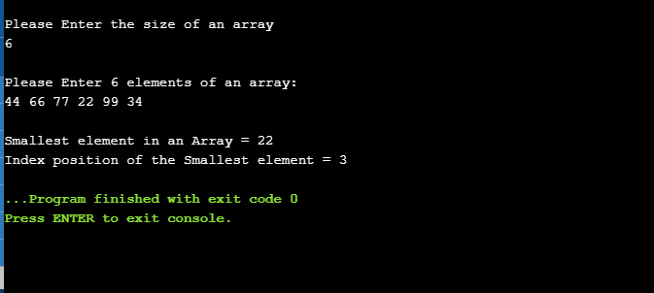

(PROGRAM-2)
AIM: Print the largest of 2 numbers using conditional operators.
SOURCE CODE:
#include <stdio.h>
int main()
{
// variable declaration
int n1 = 5, n2 = 10, max;
// Largest among n1 and n2
max = (n1 > n2) ? n1 : n2;
// Print the largest number
printf("Largest number between %d and %d is %d. ",n1, n2, max);
return 0;
}
OUTPUT:
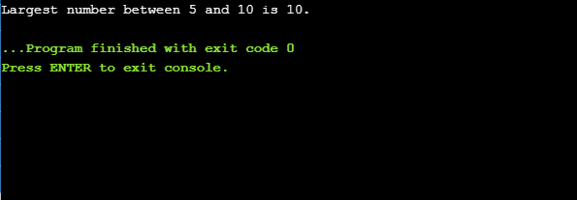

(PROGRAM-3)

AIM: Print pattern
1
12
123
1234
12345
SOURCE CODE:
#include <stdio.h>
int main()
{
int i, j, N;
printf("Enter N: ");
scanf("%d", &N);
for(i=1; i<=N; i++)
{
// Logic to print numbers
for(j=i; j>=1; j--)
{
printf("%d", j);
}
printf("\n");
}
return 0;
}
OUTPUT: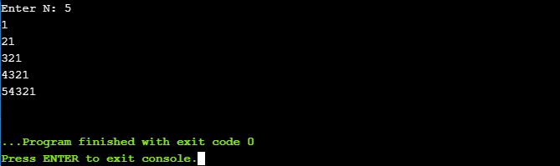

(PROGRAM-4)

AIM: Print table of a number using switch case.
SOURCE CODE:
#include<stdio.h>
#include<conio.h>
void main()
{
clrscr();
int n,i=1;
printf("Enter a number");
scanf("%d",&n);
switch(i)
{
case 1:printf("%d x %d = %d\n",i,n,i*n);i++;
case 2:printf("%d x %d = %d\n",i,n,i*n);i++;
case 3:printf("%d x %d = %d\n",i,n,i*n);i++;
case 4:printf("%d x %d = %d\n",i,n,i*n);i++;
case 5:printf("%d x %d = %d\n",i,n,i*n);i++;
case 6:printf("%d x %d = %d\n",i,n,i*n);i++;
case 7:printf("%d x %d = %d\n",i,n,i*n);i++;
case 8:printf("%d x %d = %d\n",i,n,i*n);i++;
case 9:printf("%d x %d = %d\n",i,n,i*n);i++;
case 10:printf("%d x %d = %d\n",i,n,i*n);i++;
default:break;
}
getch();
}

OUTPUT:
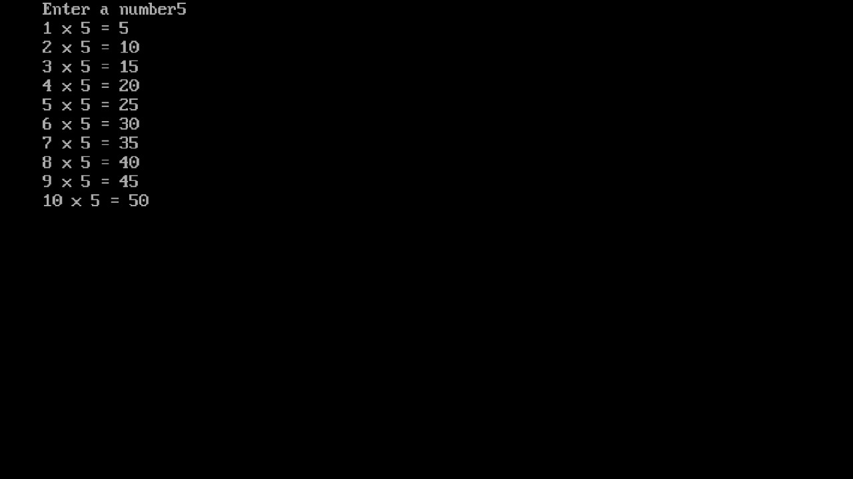

(PROGRAM-5)

AIM: WAP to perform insertion sort.
SOURCE CODE:
#include <stdio.h>
int main()
{
int n, i, j, temp;
int arr[64];
printf("Enter number of elements\n");
scanf("%d", &n);

printf("Enter %d integers\n", n);
for (i = 0; i < n; i++)
{
scanf("%d", &arr[i]);
}
for (i = 1 ; i <= n - 1; i++)
{
j = i;
while ( j > 0 && arr[j-1] > arr[j])
{
temp = arr[j];
arr[j] = arr[j-1];
arr[j-1] = temp;
j--;
}
}
printf("Sorted list in ascending order:\n");
for (i = 0; i <= n - 1; i++)
{
printf("%d\n", arr[i]);
}
return 0;
}
OUTPUT:
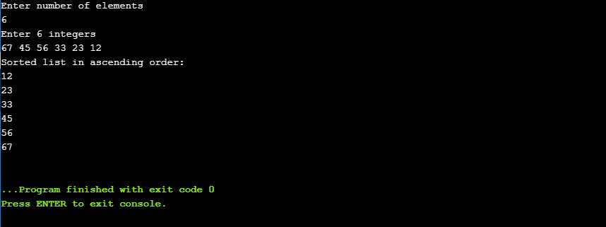

(PROGRAM-6)

AIM: Copy one string to another.
SOURCE CODE:
#include <iostream>
using namespace std;
int main()
{
string s1, s2;
cout << "Enter string s1: ";
getline (cin, s1);
s2 = s1;
cout << "s1 = "<< s1 << endl;
cout << "s2 = "<< s2;
return 0;
}

OUTPUT:

(PROGRAM-7)

AIM: Program to reverse a string.
SORCE CODE:
#include<iostream>
#include<string.h>
using namespace std;
int main ()
{
char str[50], temp;
int i, j;
cout << "Enter a string : ";
gets(str);
j = strlen(str) - 1;
for (i = 0; i < j; i++,j--)
{
temp = str[i];
str[i] = str[j];
str[j] = temp;
}
cout << "\nReverse string : " << str;
return 0;
}
OUTPUT:
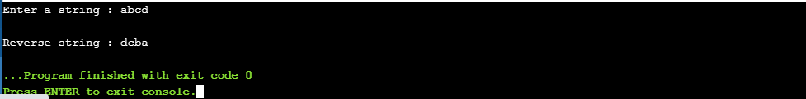

(PROGRAM-8)

AIM: Delete all vowels from string.
SOURCE CODE:
#include <stdio.h>
#include <string.h>
int check_vowel(char);
int main()
{
char s[100], t[100];
int c, d = 0;
printf("Enter a string to delete vowels\n");
gets(s);
for(c = 0; s[c] != '\0'; c++) {
if(check_vowel(s[c]) == 0) { // If not a vowel
t[d] = s[c];
d++;
}
}
t[d] = '\0';
strcpy(s, t); // We are changing initial string. This is optional.
printf("String after deleting vowels: %s\n", s);
return 0;
}
int check_vowel(char ch)
{
if (ch == 'a' || ch == 'A' || ch == 'e' || ch == 'E' || ch == 'i' || ch == 'I' || ch =='o' || ch=='O' || ch == 'u' || ch == 'U')
return 1;
else
return 0;
}
OUTPUT:
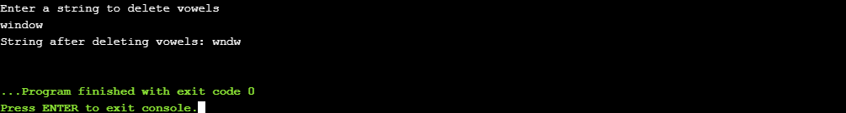

(PROGRAM-9)

AIM: Program to count numbers of words.
SOURCE CODE:
#include<iostream>
#include<string.h>
using namespace std;
int main ()
{
char str[50];
int count = 0, i;
cout << "Enter a string : ";
gets(str);
for (i = 0; str[i] != '\0';i++)
{
if (str[i] == ' ')
count++;
}
cout << "Number of words in the string are: " << count + 1;
return 0;
}
OUTPUT:
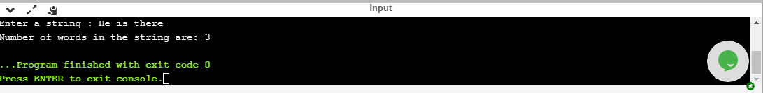

(PROGRAM-10)

AIM: Create a simple class addition (add two integers).
SOURCE CODE:
#include <iostream>
using namespace std;
class Mathematics {
int x, y;
public:
void input() {
cout << "Enter two integers\n";
cin >> x >> y;
}
void add() {
cout << "Result: " << x + y;
}
};
int main()
{
Mathematics m; // Creating an object of the class
m.input();
m.add();
return 0;
}

OUTPUT:
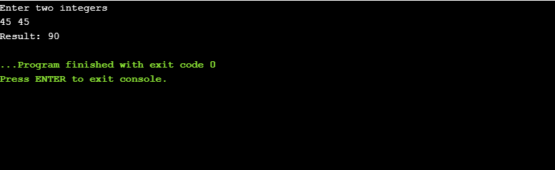

(PROGRAM-11)

AIM: Create a student record including (name, branch, roll no.) using class and print the details of the student.
SOURCE CODE:
#include<iostream>
using namespace std;
class student
{
private:

char name[20],roll[10],branch[10];
int sem;
public:
void input();
void display();
};
void student::input()
{
cout<<("Enter Name:");
cin>>name;
cout<<("Enter Roll No.:");
cin>>roll;
cout<<("Enter Branch:");
cin>>branch;
cout<<("Enter Sem:");
cin>>sem;
}
void student::display()
{
cout<<"\nName:"<<name;
cout<<"\nRoll no.:"<<roll;
cout<<"\nBranch:"<<branch;
cout<<"\nSem:"<<sem;
}
int main()
{
student s;
s.input();
s.display();
}
OUTPUT:
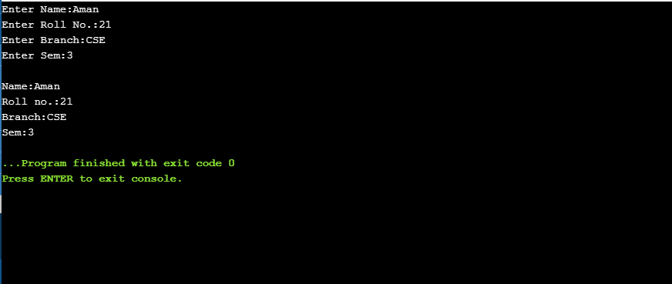

(PROGRAM-12)

AIM: Check if a number is prime or not using class.
SOURCE CODE:
#include<iostream>
#include<conio.h>
using namespace std;
// Class Declaration
class prime {
//Member Variable Declaration
int a, k, i;
public:
prime(int x) {
a = x;
}
// Object Creation For Class
void calculate() {
k = 1;
{
for (i = 2; i <= a / 2; i++)
if (a % i == 0) {
k = 0;
break;
} else {
k = 1;
}
}
}
void show() {
if (k == 1)
cout << "\n" << a << " is Prime Number.";
else
cout << "\n" << a << " is Not Prime Numbers.";
}
};
//Main Function
int main() {
int a;
cout << "Enter the Number:";
cin>>a;
// Object Creation For Class
prime obj(a);
// Call Member Functions
obj.calculate();
obj.show();
getch();
return 0;
}
OUTPUT:
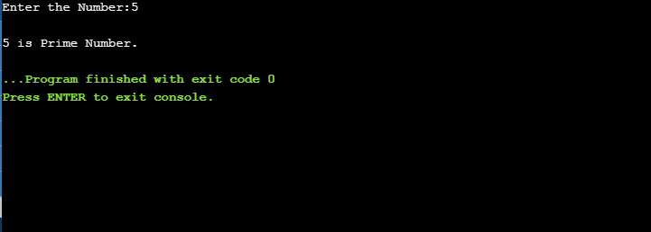

(PROGRAM-13)

AIM: Compare area of two rectangles using this pointer.
SOURCE CODE:
#include<iostream>
#include<conio.h>
using namespace std;
class recarea{
private:
int l,b;
public:
recarea( int l, int b){
this->l=l;
this->b=b;}
int area (){
return l*b;
}
int compare(recarea r)
{
return this->area()<r.area();
}
};
int main(){
recarea r1(4,7);
recarea r2(5,7);
if(r2.compare(r1))
{
cout<<"Rectangle1 is greater";
}
else
{
cout<<"Rectangle2 is greater";
}
getch();
return 0;
}
OUTPUT:
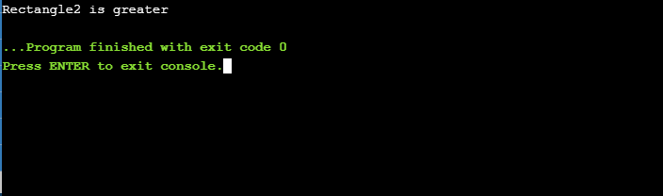

(PROGRAM-14)

AIM: WAP to use the private data member of a class using pointers.
SOURCE CODE:
#include<iostream>
using namespace std;

class Complex{
int real, imaginary;
public:
void getData(){
cout<<"The real part is "<< real<<endl;
cout<<"The imaginary part is "<< imaginary<<endl;
}

void setData(int a, int b){
real = a;
imaginary = b;
}

};
int main(){
// Complex c1;
// Complex *ptr = &c1;
Complex *ptr = new Complex;
// (*ptr).setData(1, 54); is exactly same as
ptr->setData(1, 54);

// (*ptr).getData(); is as good as
ptr->getData();

// Array of Objects
Complex *ptr1 = new Complex[4];
ptr1->setData(1, 4);
ptr1->getData();
return 0;
}
OUTPUT:
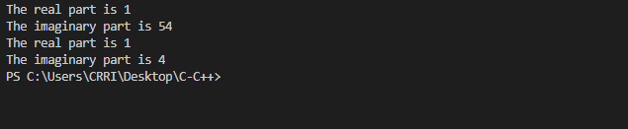

(PROGRAM-15)

AIM: WAP to differentiate between the static variable are class variables and are not object
variables.
SOURCE CODE:
#include <iostream>
using namespace std;
class myClass
{
static int a;int b ;
public:
static int c;
void set(int i,int j)
{ a++; b=i; c=j;}
void get()
{cout<<"\nStatic a:" << a <<".Non-Static b:"<< b <<".Static c:"<< c;}
};
int myClass::a=10;
int myClass::c;
int main()
{
cout<<"\nPublic Static c:" <<myClass::c;
myClass m1,m2;
m1.set(1,2);
m2.set(3,4);
m1.get();
m2.get();
return 0;
}

OUTPUT:
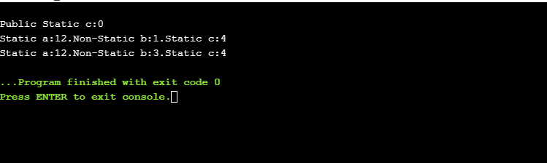

(PROGRAM-16)

AIM: Write a program to find the sum and difference of two distances.

SOURCE CODE:
#include<iostream>
using namespace std;

class dist2;
class dist1
{
public:
float mtr, cm;
public:
void accept()
{
cout<<"\n Enter Data in Meter & Centimeter : ";
cin>>mtr>>cm;
}
friend void diff(dist1 d1, dist2 d2);
friend void sum(dist1 d1, dist2 d2);
};
class dist2
{
float feet, inch;
public:
void accept()
{
cout<<"\n Enter Data in Feet & Inch : ";
cin>>feet>>inch;
}
friend void difference(dist1 d1, dist2 d2);
friend void sum(dist1 d1, dist2 d2);
};
void difference(dist1 d1,dist2 d2)
{
int n1, n2, n3, ans, m, c, f, in;
n1=d2.inch*2.54;
n2=d2.feet*0.30;
n3=d1.mtr*100;
ans=((d1.cm + n3) - (n1 + n2));
m=ans/100;
c=ans%100;
cout<<"\n --------------------------------------------------------------------";
cout<<"\n Difference in Meters & Centimeters = "<<m<<" mtrs & "<<c<<" cms";
f=m/0.30;
in=c/2.54;
cout<<"\n Difference in Feets & Inches = "<<f<<" feets & "<<in<<" inches";
}
void sum(dist1 d1, dist2 d2)
{
int n1, n2, n3, ans, m, c, f, in;
n1=d2.inch*2.54;
n2=d2.feet*0.30;
n3=d1.mtr*100;
ans=((d1.cm + n3) + (n1+n2));
m=ans/100;
c=ans%100;
cout<<"\n ------------------------------------------------------------------";
cout<<"\n Sum in Meters & Centimeters = "<<m<<" mtrs & "<<c<<" cms";
f=m/0.30;
in=c/2.54;
cout<<"\n Sum in Feets & Inches = "<<f<<" feets & "<<in<<" inches";
}
int main()
{
dist1 d1;
dist2 d2;
d1.accept();
d2.accept();
difference(d1,d2);
sum(d1,d2);
return 0;
}

OUTPUT:
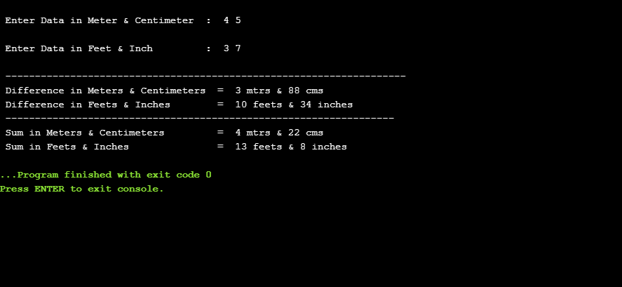

(PROGRAM-17)

AIM: Write a program to accept, display and sort employee data.
SOURCE CODE:
#include <iostream>
#include <stdio.h>
#include <string.h>
#include <cstdlib>
using namespace std;

class staff
{
int staff_id;
char name[20];
float salary;

public:
staff()
{
}
void accept()
{
cout << "\n Enter Staff Id : ";
cin >> staff_id;
cout << "\n Enter Staff Name : ";
cin >> name;
cout << "\n Enter Salary : ";
cin >> salary;
}
void display();
friend void sort(char nm[], int n, staff *s);
void operator=(staff s1);
};
void staff::operator=(staff s1)
{
staff_id = s1.staff_id;
strcpy(name, s1.name);
salary = s1.salary;
}
void staff::display()
{
cout << "\n Staff Id : " << staff_id;
cout << "\n Name : " << name;
cout << "\n Salary : " << salary << "\n";
}
void sort(char nm[], int n, staff *s) //Function for sorting the data by employee name
{
staff temp;
for (int i = 0; i < n; i++)
{
for (int j = i + 1; j < n; j++)
{
int r = strcmp(s[i].name, s[j].name);
if (r > 0)
{
temp = s[i];
s[i] = s[j];
s[j] = temp;
}
}
}
}
int main()
{
int ch;
staff *s;
int n;
cout << "\n Enter No.of Records You Want : ";
cin >> n;
s = new staff[n];
do
{
cout << "\n 1. Accept Data ";
cout << "\n 2. Display Data ";
cout << "\n 3. Sort Data by Name ";
cout << "\n 4. Exit: ";
cout << "\n\n Enter Your Choice : ";
cin >> ch;
switch (ch)
{
case 1:
for (int i = 0; i < n; i++)
{
cout << "\n\n Enter Data for Employee " << i + 1 << "\n";
s[i].accept();
}
break;
case 2:
for (int i = 0; i < n; i++)
{
s[i].display();
}
break;
case 3:
sort("a", n, s); //Passing parameter to sort() function
cout << "\n Data is Sorted!!!\n";
break;
case 4:
exit(0);
default:
cout << "\n Invalid Choice . . .";
}
} while (ch != 4);
return 0;
}

OUTPUT:
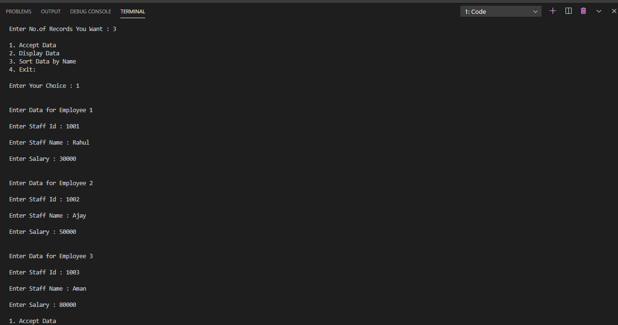

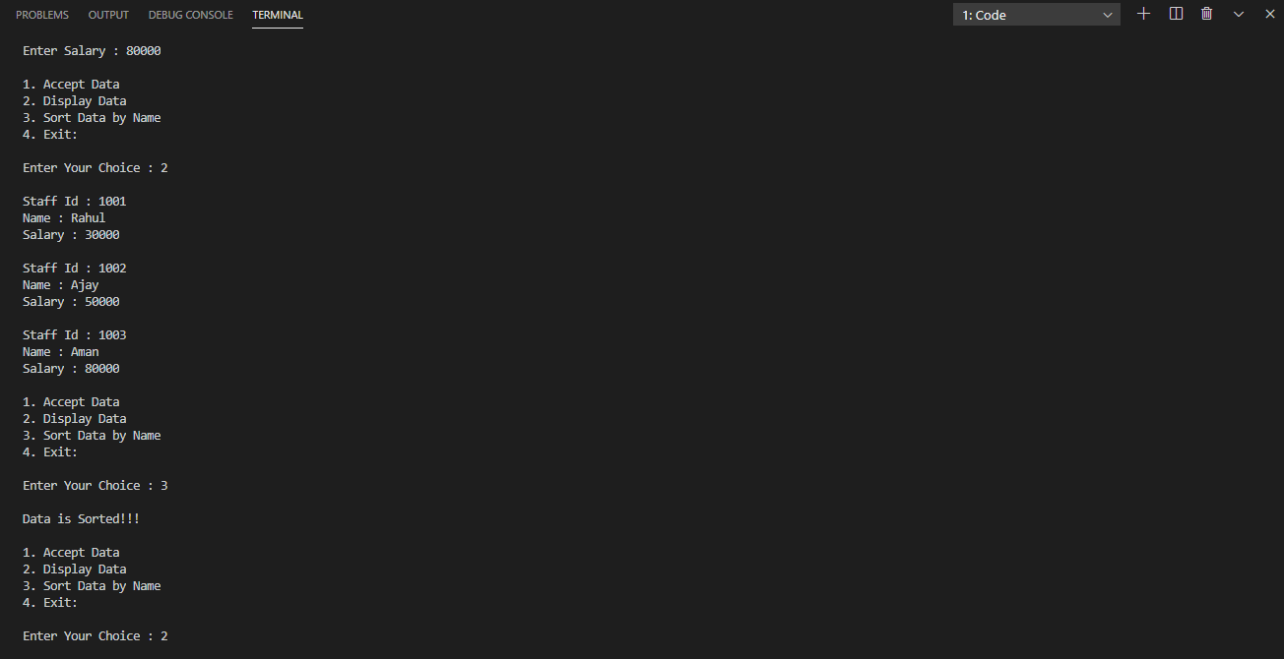
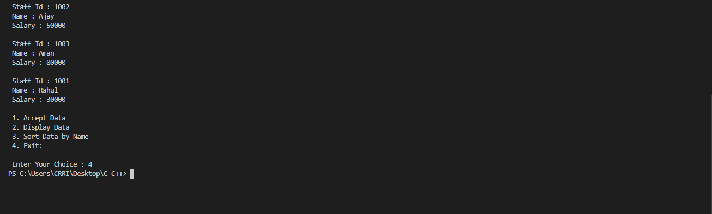

(PROGRAM-18)

AIM: Write a program function overloading using binary operator.
SOURCE CODE:
#include <iostream>
using namespace std;

class Complex
{
private:
float real;
float imag;

public:
// Constructor to initialize real and imag to 0
Complex() : real(0), imag(0) {}

void input()
{
cout << "Enter real and imaginary parts respectively: ";
cin >> real;
cin >> imag;
}

// Overload the + operator
Complex operator+(const Complex &obj)
{
Complex temp;
temp.real = real + obj.real;
temp.imag = imag + obj.imag;
return temp;
}

void output()
{
if (imag < 0)
cout << "Output Complex number: " << real << imag << "i";
else
cout << "Output Complex number: " << real << "+" << imag << "i";
}
};

int main()
{
Complex complex1, complex2, result;

cout << "Enter first complex number:\n";
complex1.input();

cout << "Enter second complex number:\n";
complex2.input();

result = complex1 + complex2;
result.output();

return 0;
}

OUTPUT:
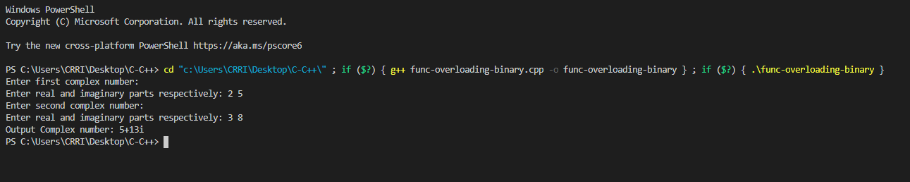

(PROGRAM-19)

AIM: Write a program function overloading using unary operator.
SOURCE CODE:
#include <iostream>
using namespace std;

class IncreDecre
{
int a, b;

public:
void accept()
{
cout << "\n Enter Two Numbers : \n";
cout << " ";
cin >> a;
cout << " ";
cin >> b;
}
void operator--() //Overload Unary Decrement
{
a--;
b--;
}
void operator++() //Overload Unary Increment
{
a++;
b++;
}
void display()
{
cout << "\n A : " << a;
cout << "\n B : " << b;
}
};
int main()
{
IncreDecre id;
id.accept();
--id;
cout << "\n After Decrementing : ";
id.display();
++id;
++id;
cout << "\n\n After Incrementing : ";
id.display();
return 0;
}
OUTPUT:
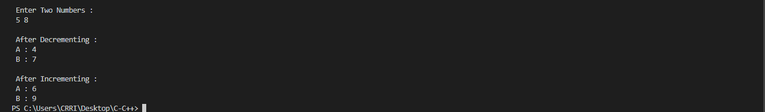

(PROGRAM-20)

AIM: Write a program function overloading using friend – function.
SOURCE CODE:
#include <iostream>

using namespace std;

class Distance
{
public:
// Member Object
int feet, inch;

// No Parameter Constructor
Distance()
{
this->feet = 0;
this->inch = 0;
}

// Constructor to initialize the object's value
// Parametrized Constructor
Distance(int f, int i)
{
this->feet = f;
this->inch = i;
}

// Declaring friend function using friend keyword
friend Distance operator+(Distance &, Distance &);
};

// Implementing friend function with two parameters
Distance operator+(Distance &d1, Distance &d2) // Call by reference
{
// Create an object to return
Distance d3;

// Perform addition of feet and inches
d3.feet = d1.feet + d2.feet;
d3.inch = d1.inch + d2.inch;

// Return the resulting object
return d3;
}

// Driver Code
int main()
{
// Declaring and Initializing first object
Distance d1(8, 9);

// Declaring and Initializing second object
Distance d2(10, 2);

// Declaring third object
Distance d3;

// Use overloaded operator
d3 = d1 + d2;

// Display the result
cout << "\nTotal Feet & Inches: " << d3.feet << "'" << d3.inch;
return 0;
}

OUTPUT:
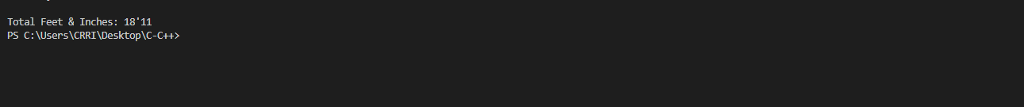

(PROGRAM-21)

AIM: Write a C++ program to add 2 integer or floating point number using constructor overloading.
SOURCE CODE:
#include <iostream>
using namespace std;

int sum(int, int);
float sum(float, float);
float sum(int, float);

int main()
{
int num1, num2, x;
float num3, num4, y;
cout << "Enter two integer numbers: ";
cin >> num1 >> num2;
//This will call the first function
cout << "Result: " << sum(num1, num2) << endl;

cout << "Enter two float numbers: ";
cin >> num3 >> num4;
//This will call the second function
cout << "Result: " << sum(num3, num4) << endl;

cout << "Enter one int and one float number: ";
cin >> x >> y;
//This will call the third function
cout << "Result: " << sum(x, y) << endl;
return 0;
}
int sum(int a, int b)
{
return a + b;
}
float sum(float a, float b)
{
return a + b;
}

float sum(int a, float b)
{
return a + b;
}

OUTPUT:
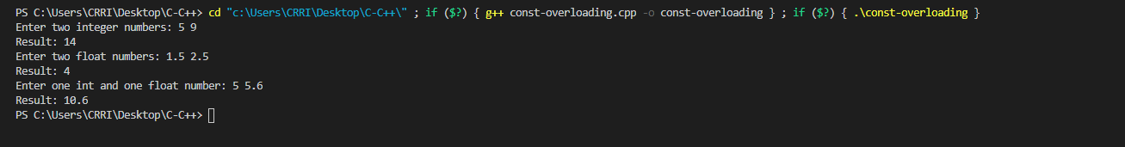

(PROGRAM-22)

AIM: Write a C++ program to find the area of square, rectangle, circle and triangle by using function overloading.
SOURCE CODE:
/* C++ program to find Area using Function Overloading */

#include<iostream>
using namespace std;
int area(int);
int area(int,int);
float area(float);
float area(float,float);
int main()
{
int s,l,b;
float r,bs,ht;
cout<<"Enter side of a square:";
cin>>s;
cout<<"Enter length and breadth of rectangle:";
cin>>l>>b;
cout<<"Enter radius of circle:";
cin>>r;
cout<<"Enter base and height of triangle:";
cin>>bs>>ht;
cout<<"Area of square is "<<area(s);
cout<<"\nArea of rectangle is "<<area(l,b);
cout<<"\nArea of circle is "<<area(r);
cout<<"\nArea of triangle is "<<area(bs,ht);
}
int area(int s)
{
return(s*s);
}
int area(int l,int b)
{
return(l*b);
}
float area(float r)
{
return(3.14*r*r);
}
float area(float bs,float ht)
{
return((bs*ht)/2);
}
OUTPUT:
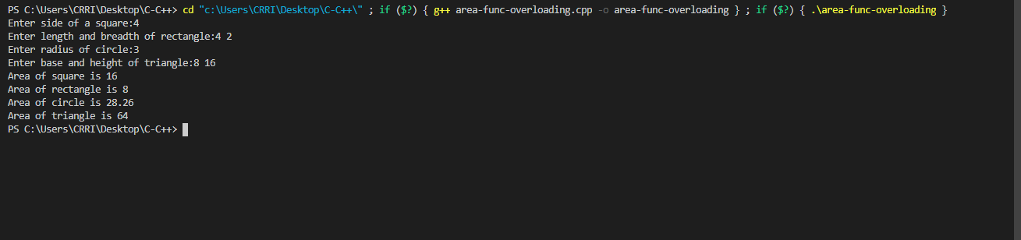

(PROGRAM-23)

AIM: Write a program to overload input and output (<< and >>) operators.
SOURCE CODE:
#include <iostream>
using namespace std;

class Complex
{
private:
int real, imag;
public:
Complex(int r = 0, int i =0)
{ real = r; imag = i; }
friend ostream & operator << (ostream &out, const Complex &c);
friend istream & operator >> (istream &in, Complex &c);
};

ostream & operator << (ostream &out, const Complex &c)
{
out << c.real;
out << "+i" << c.imag << endl;
return out;
}

istream & operator >> (istream &in, Complex &c)
{
cout << "Enter Real Part ";
in >> c.real;
cout << "Enter Imaginary Part ";
in >> c.imag;
return in;
}

int main()
{
Complex c1;
cin >> c1;
cout << "The complex object is ";
cout << c1;
return 0;
}

OUTPUT:

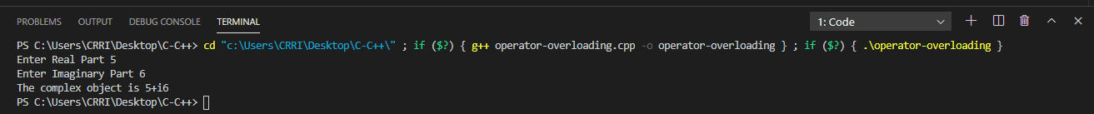

PROGRAM-24

AIM: C++ program to calculate power of a number using class.
SOURCE CODE:
#include<iostream>
#include<iomanip>
using namespace std;
class pow
{
private:
long double number;
int power;
public:
void getdata(long double i,int j)
{
number=i;
power=j;
}
long double findpow()
{
long double num2=number;
while(power>1)
{
number*=num2;
power--;
}
return number;
}
};
int main()
{
pow obj;
long double num,number;
int p;
cout<<"Enter number : ";
cin>>num;
cout<<"Enter the power of number : ";
cin>>p;
obj.getdata(num,p);
number=obj.findpow();
cout<<num<<"^"<<p<<" = "<<setprecision(14)<<number;
return 0;
}

OUTPUT:
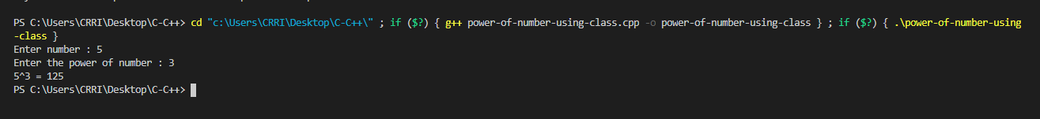

PROGRAM-25

AIM: Create record of 5 employee using array of objects.
SOURCE CODE:
#include <iostream>
using namespace std;

class Employee
{
int id;
int salary;

public:
void setId(void)
{
salary = 120;
cout << "Enter the id of employee" << endl;
cin >> id;
}
void getId(void)
{
cout << "The id of this employee is " << id << endl;
}
};

int main()
{
Employee fb[5];
for (int i = 0; i < 5; i++)
{
fb[i].setId();
fb[i].getId();
}
return 0;
}
OUTPUT:
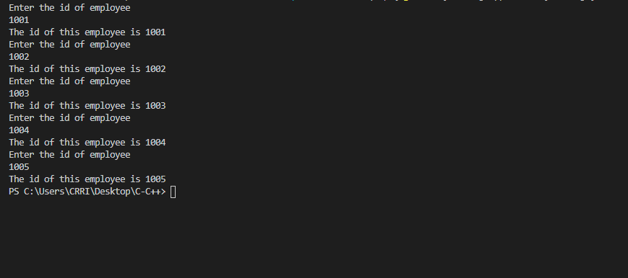

PROGRAM-26

AIM: Write a C++ program to create a class Animal with functions eats and sleep and inherit with the class name Dog having function barks.
SOURCE CODE:
#include <iostream>
using namespace std;

// base class
class Animal
{

public:
void eat()
{
cout << "I can eat!" << endl;
}

void sleep()
{
cout << "I can sleep!" << endl;
}
};

// derived class
class Dog : public Animal
{

public:
void bark()
{
cout << "I can bark! Woof woof!!" << endl;
}
};

int main()
{
// Create object of the Dog class
Dog dog1;

// Calling members of the base class
dog1.eat();
dog1.sleep();

// Calling member of the derived class
dog1.bark();

return 0;
}
OUTPUT:
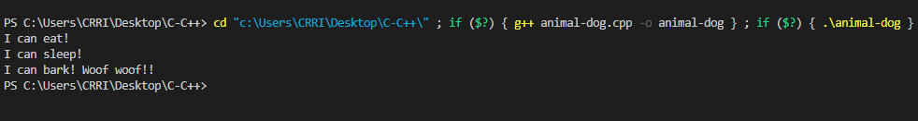

PROGRAM-27

AIM: Write a C++ program to create a class Animal with functions eats and sleep and inherit with the class name Dog having function barks. Make the program multiple inheritance by adding one more class YoungOne with function name of YoungOne.
SOURCE CODE:
#include <iostream>
using namespace std;

// base class
class Animal
{

public:
void display()
{
cout << "It can eat!" << endl;
cout << "It can sleep!" << endl;
}
};

// derived class
class Dog : public Animal
{
};

// derived class
class YoungOne : public Dog
{
};

int main()
{
// Create object of the Dog class
YoungOne puppy;

puppy.display();
return 0;
}
OUTPUT:
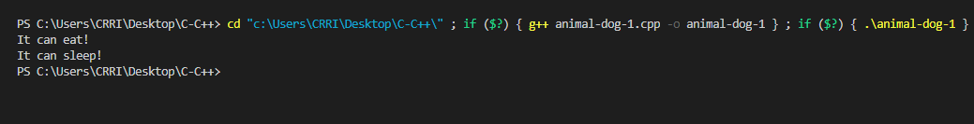

PROGRAM-28

AIM: Write a C++ program to show multilevel inheritance with class Mammal, Winged Mammal at same level and class Bat that inherits both.
SOURCE CODE:
#include <iostream>
using namespace std;

class Mammal {
public:
Mammal()
{
cout << "Mammals can give direct birth." << endl;
}
};

class WingedAnimal {
public:
WingedAnimal()
{
cout << "Winged animal can flap." << endl;
}
};

class Bat: public Mammal, public WingedAnimal {

};

int main()
{
Bat b1;
return 0;
}
OUTPUT:
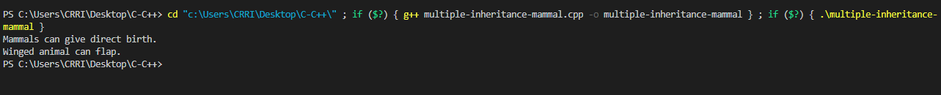

PROGRAM-29

AIM: Create the equivalent of a four-function calculator. The program should ask the user to enter a number, an operator, and another number. (Use floating point.) It should then carry out the specified arithmetical operation: adding, subtracting, multiplying, or dividing the two numbers. Use a switch statement to select the operation. Finally, display the result. When it finishes the calculation, the program should ask whether the user wants to do another calculation. The response can be ‘y’ or ‘n’.
SOURCE CODE:
#include <iostream>
using namespace std;
int main()
{
double n1, n2, ans;
char oper, ch;
do
{
cout << "\nEnter first number, operator, second number : ";
cin >> n1 >> oper >> n2;
switch (oper)
{
case '+':
ans = n1 + n2;
break;
case '-':
ans = n1 - n2;
break;
case '*':
ans = n1 * n2;
break;
case '/':
ans = n1 / n2;
break;
default:
ans = 0;
}
cout << "Answer = " << ans;
cout << "\nDo another(Enter Y or N) ? ";
cin >> ch;
} while (ch != 'n');
return 0;
}
OUTPUT:
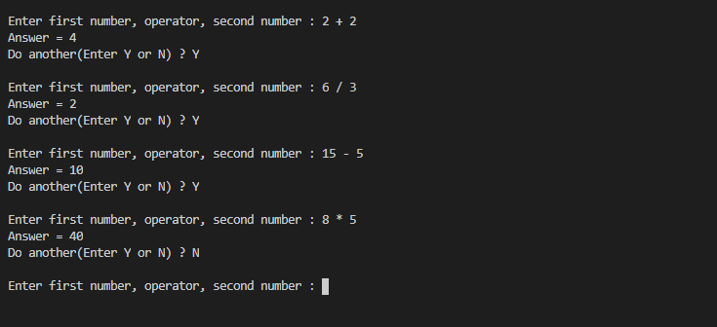

PROGRAM-30

AIM: Create two classes DM and DB which store the value of distances. DM stores distances in meters and centimeters and DB in feet and inches. Write a program that read values for the class objects and add one object of DM with another object of DB. Use a friend function to carry out the addition operation. The object that stores the results maybe a DM object or DB object, depending on the units in which the result are required. The display should be in the format of feet and inches or meters and centimeters depending on the object on display.
SOURCE CODE:
#include <iostream>
using namespace std;
class DB;
class DM
{
int meter, centimeter;

public:
void accept()
{
cout << "\n\n Enter meter and centimeter: ";
cin >> meter >> centimeter;
}

void display()
{
cout << "\n\n Meter: " << meter;
cout << "\n Centimeter: " << centimeter;
}

friend void add(DB d1, DM d2);
};

class DB
{
int feet, inches;

public:
void accept()
{
cout << "\n\n Enter feet and inches: ";
cin >> feet >> inches;
}

void display()
{
cout << "\n\n Feet: " << feet;
cout << "\n Inches: " << inches;
}

friend void add(DB d1, DM d2);
};

void add(DB d1, DM d2)
{
DM d;
int c = (d2.meter * 100 + d2.centimeter + d1.feet * 30.48 + d1.inches * 2.54);
if (c >= 100)
{
d.meter = c / 100;
d.centimeter = c % 100;
}
else
{
d.meter = 0;
d.centimeter = c;
}
d.display();
}

int main()
{
DB d1;
DM d2;

d1.accept();
d2.accept();

d1.display();
d2.display();

cout << "\n\n Addition of Meter-Centimeter";
add(d1, d2);

return 0;
}

OUTPUT:
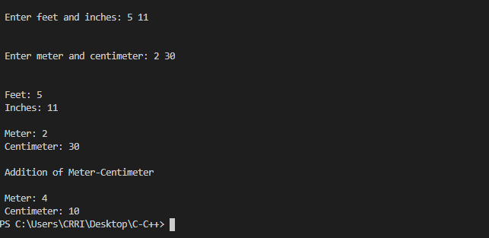

PROGRAM-31
AIM: Write a C++ program for opening and creating a file.
SOURCE CODE:
#include <iostream>
#include <fstream>

using namespace std;

int main()
{
string st = "Sai Pranav";
string st2;
// ofstream out("sample.txt");
// out<<st;

ifstream in("sample2.txt");
// in>>st2;
getline(in, st2);
cout << st2;

return 0;
}

OUTPUT:
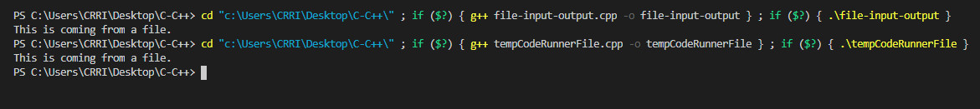

PROGRAM-32
AIM: Write a program to manipulate the file pointer using seekg, seekp, tellg and tellp.
SOURCE CODE:
#include <iostream>
#include <fstream>

using namespace std;

int main()
{

//Creating an input stream to read the content of a file
ifstream ifstream_ob;

//Opening a file named country1.txt to read its content
ifstream_ob.open("file123.txt", ios::in);

cout << "The first location in the file : " << ifstream_ob.tellg() << "\n";

char ch;

cout << "\nReading the content of file : \n";

//Read the file until EOF is reached
while (ifstream_ob)
{
ch = ifstream_ob.get();
cout << ch;
}

//Setting the EOF flag off, to allow the access of file again for reading
ifstream_ob.clear();

cout << "\n\nReading the content of file once again : \n";

//Taking the get pointer at the zero byte location from the beginning of the file
ifstream_ob.seekg(0, ios::beg);

//Reading the content of the file again
while (ifstream_ob)
{
ch = ifstream_ob.get();
cout << ch;
}

return 0;
}

file123.txt
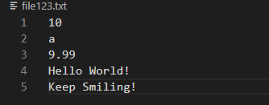

OUTPUT:
